Financial Engineering Lab 4

Question 1
a)
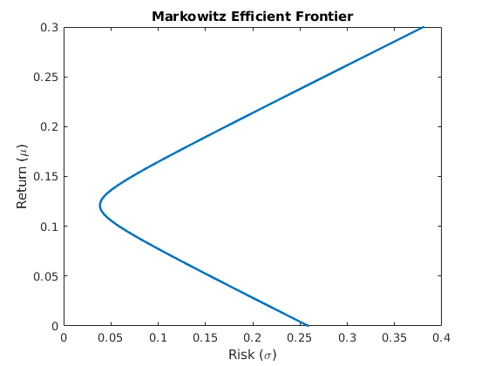
b)
Index w1 w2 w3 Return Risk
50 2.478899 -0.421101 -1.057798 0.005000 0.248337
100 2.407339 -0.392661 -1.014679 0.010000 0.237895
150 2.335780 -0.364220 -0.971560 0.015000 0.227465
200 2.264220 -0.335780 -0.928440 0.020000 0.217049
250 2.192661 -0.307339 -0.885321 0.025000 0.206650
300 2.121101 -0.278899 -0.842202 0.030000 0.196269
350 2.049541 -0.250459 -0.799083 0.035000 0.185910
400 1.977982 -0.222018 -0.755963 0.040000 0.175577
450 1.906422 -0.193578 -0.712844 0.045000 0.165274
500 1.834862 -0.165138 -0.669725 0.050000 0.155008
Part c) and d)
Portfolio for 18% return with Minimum Risk:
Weights: w1 = -0.025688 w2 = 0.574312 w3 = 0.451376
Risk = 0.130568
Portfolio for 15% risk with Minimum Return:
Return = 0.052400
Weights: w1 = 1.800514 w2 = -0.151486 w3 = -0.649028
e)
Portfolio for 15% risk with Maximum Return:
Return = 0.189600
Weights: w1 = -0.163083 w2 = 0.628917 w3 = 0.534165
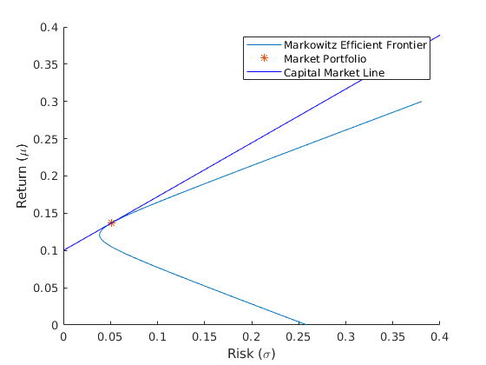
f)
Portfolio for 10% risk
Return = 0.172265
Weight of Risk-Free Asset = -0.968067
Weight of Risky Assets w1 = 1.168540 w2 = 0.645772 w3 = 0.153755
Portfolio for 25% risk
Return = 0.280662
Weight of Risk-Free Asset = -3.920166
Weight of Risky Assets w1 = 2.921349 w2 = 1.614430 w3 = 0.384388

Question 2
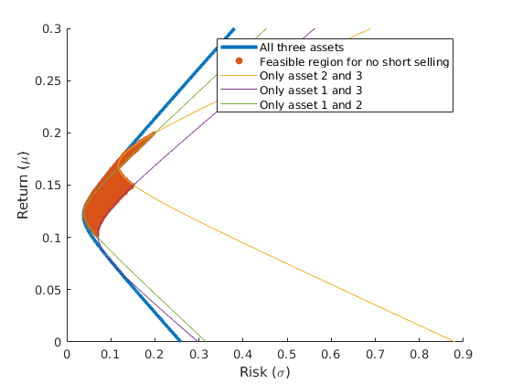
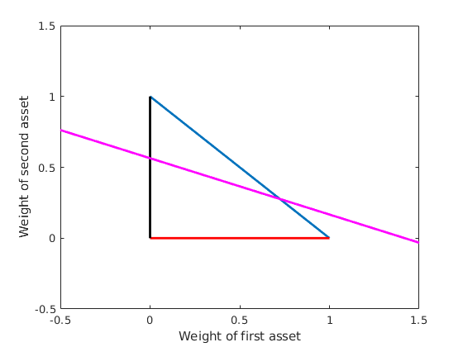
Equations for the weights are (w1,w2,w3)
Question 3

Monthly Stock data Taken from 1-03-2015 to 1-02-2020 (60 Data Points) for 10. Data can be found in Final_Data.csv.
Stocks Taken – AAPL (Apple Inc), AMZN(Amazon), FB(Facebook), GOOG(Google),JBLU(Jet Blue Airways), NFLX(Netflix), AAL(American Air Lines), S(Sprint), SFTBY(SoftBank), TSLA(Tesla)
All the Stock prices are in USD.
First 8 Records -
 | Date | AAPL | AMZN | FB | GOOG | JBLU | NFLX | AAL | S | SFTBY | TSLA
1 | 2015-03-01 | 130.2800 | 388.4200 | 86.0700 | 576.3277 | 19.6000 | 68.6071 | 56.0500 | 5.4500 | 15.4200 | 206.1900
2 | 2015-04-01 | 134.5400 | 452.6500 | 85.5900 | 569.5762 | 21.2800 | 82.3043 | 53.4700 | 5.3900 | 16.4800 | 238.7500
3 | 2015-05-01 | 132.9700 | 439.0000 | 81.8500 | 544.1900 | 22.4000 | 90.2057 | 50.3000 | 5.2900 | 15.7850 | 252.8700
4 | 2015-06-01 | 131.3900 | 447.0400 | 89.4000 | 543.7400 | 21.6000 | 100.8914 | 44.3800 | 4.8100 | 15.2500 | 271.4100
5 | 2015-07-01 | 132.9700 | 580.5700 | 99.2400 | 678.6400 | 24.1900 | 117.8800 | 43.8100 | 4.6000 | 14.8050 | 286.6500
6 | 2015-08-01 | 122.5700 | 542.7400 | 98.7400 | 674.9000 | 24.6400 | 129.2900 | 44.4500 | 5.2900 | 15.7250 | 271.0000
7 | 2015-09-01 | 116.8900 | 549.7800 | 96.4900 | 650.9000 | 27.3600 | 111.2400 | 44.5900 | 5.2200 | 14.1400 | 271.5700
8 | 2015-10-01 | 121.2200 | 630.7200 | 105.1200 | 730.0000 | 27.0900 | 115.8300 | 46.7700 | 5.1200 | 14.2950 | 249.8400

a)
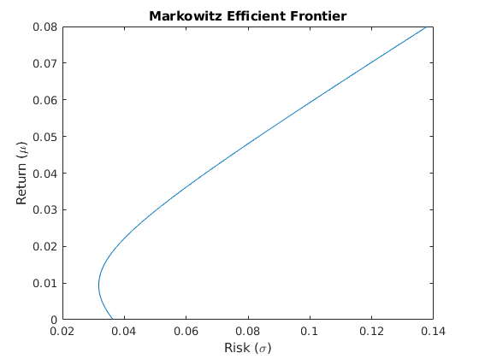
b)
Market Portfolio:
Return = 0.042685
Risk = 0.070823
Weight of Assets w1 = 0.288343 w2 = 0.444927 w3 = 0.202027 w4 = 0.162054 w5 = 0.176630 w6 = 0.126781 w7 = -0.759517 w8 = 0.278773 w9 = -0.080182 w10 = 0.160165
c)
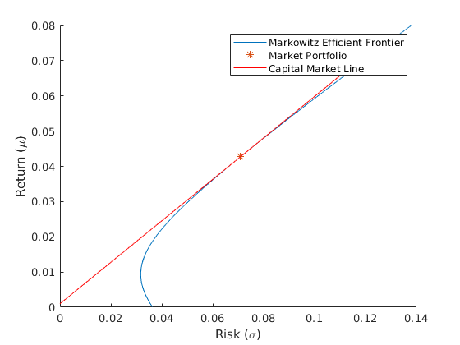
d)
